1-MethylButylTosylate
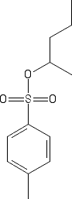
Main Function Group: Secondary Tosylate
- Common Name – 1-MethylButylTosylate
- IUPAC Name – Sec-Butyl 4-Methylbenzenesulfonate
- Molecular Weight – 242.34 g/mol
- Melting Point – N/A
- Boiling Point – N/A

